**E-MOVIE TICKETING SYSTEM FOR CINEMA THEATER**

**SIHMA NUSRI SAMSUDEEN**

**REGISTRATION NUMBER: BAT/IT/2017/FT/067**

**ATI - BATTICALOA**

**SRI LANKA INSTITUTE OF ADVANCED TECHNOLOGICAL EDUCATION**

**2019**

**E-MOVIE TICKETING SYSTEM FOR CINEMA THEATER**

**SIHMA NUSRI SAMSUDEEN**

**Registration Number: BAT/IT/2017/FT/067**

A Software project is submitted to the Department of Information Technology, ATI Batticaloa in Partial Fulfillment of the Requirements of the Degree of Higher National Diploma in Information Technology.

**ATI - BATTICALOA**

**SRI LANKA INSTITUTE OF ADVANCED TECHNOLOGICAL EDUCATION**

**2019**

**CERTIFICATION**

This is to certify that the project entitled **“E-MOVIE TICKETING SYSTEM”** submitted by **S.Sihma Nusri, Registration Number: BAT/IT/2017/FT/067** to the Faculty of ICT, ATI Batticaloa, in Partial Fulfillment of the Requirements of the Higher National Diploma in Information Technology is her original work based on the study carried out independently by her during the period of study under my guidance, supervision and approved for submission.

…………………………………..

Signature of the Supervisor,

Mr. P. Pirapuraj,

Lecturer in Information Technology,

ATI Batticaloa.

Date: ………………………………..

**DECLARATION**

I do hereby declare that the work reported in this project report was exclusively carried out by me under the supervision of Mr.P.Pirapuraj Assistant Lecturer of the Department of Information Technology, Advanced Technological Institute Batticaloa, Sri Lanka. It describes the result of my own and independent work except where due reference has been made in the text. No part of this project report has been submitted earlier or concurrently for the same or any other diploma.

Name: S.Sihma Nusri

Reg.no.: BAT/IT/2017/F/067

Supervisor: ………………………….............. Date: ……………

Signature : ……………………

Head of the Department: ...................................

Date: ………………………

Signature: ................................…

**ACKNOWLEDGEMENT**

The success and final outcome of this project required a lot of guidance and assistance from many people and my extremely fortunate to have got this all along the completion of this project work. Whatever I have done is only due to such guidance and assistance and I would not forget to thank them. I respect and thank our project supervisor Mr.S.Jayapalan sir and other lecturers for giving me an opportunity to do this project work and providing me all support and guidance which made me complete the project on time, I extremely grateful to him for providing such a nice support and guidance.

I am really grateful because I could manage to complete this project within the time given by. This project cannot be completed without the effort and co-operation from my friends. I would like to express my gratitude to my friends and respondents for support and willingness to spend some time with me.

Thank you

**ABSTRACT**

This E-movie ticketing is a faster, cleaner and a tad more personal website, specially designed to make your booking experience better.

Customers may view the contents of any movie show at any time and may book any movie ticket as needed. The program automatically calculates the subtotal and grand total. When a visitor decides to finally book the ticket, the order information including the buyer’s name, address and billing instruction is stored in the database securely and payment has been made.

The combo booking is also provided at the time of booking the ticket and there’s a wonderful facility of delivering the combos at your seat when you are watching the movie.

You need to register a new user whenever you have first visited or site then for future it will be stored in our database permanently and you can book movie ticket at any time you want with this username and password.

**TABLE OF CONTENTS**

Certification iii

Declaration iv

Acknowledgment v

Abstract vi

CHAPTER 1

1 INTRODUCTION

1. Introduction 1
2. Objective 2
3. Description of existing system 2
4. Drawbacks of the Existing System 3
5. Circumstances leading to the system 3

CHAPTER 2

2 SYSTEM ANALYSIS

1. System Analysis 4
2. Problem Analysis 5
3. Problem Analysis Approaches 5
4. Preliminary Evaluation 5
5. Hardware Configuration 6
6. Software Configuration 6
7. Requirements

Functional Requirements 7

Non-Functional Requirements 8

1. Requirement Analysis

Information Gathering 8

Methodology for the project 9

Data Source 9

Fact Finding Techniques 10

Data Collection Methods 10

1. Feasibility Analysis 12

Technical Feasibility 12

Economical Feasibility 12

Schedule Feasibility 12

CHAPTER 3

3 SYSTEM DESIGN 13

1. System Design 13
2. DFD Diagram 14
3. Physical Design 15
4. Interface design
   1. Interface designs 15
   2. Application Interfaces 16

CHAPTER 4

4SYSTEM IMPLEMENTATION 20

1. End user Training 20
2. End User Education 20
3. Training of application software 21
4. Post Implementation View 21

CHAPTER 5

SOFTWARE TESTING 22

1. White Box Testing 23
2. Black box Testing 23
3. Scope of Testing 23
4. Test Plan 23
5. Test case description 25
6. Validation 26
7. System Security Measures 26

CHAPTER 6

DATABASE MANAGEMENT

1. Database Management System 27
2. Database Backup 28
   1. Backup Data 28
   2. Backup Media 28

CHAPTER 7

CRITICAL APPRAISAL OF PROJECT

1. Review of the Project Development Process 29
2. Strengths and Weaknesses
   1. Strengths 29
   2. Weaknesses 29
3. Future Scope and further enhancement of the Project
   1. Future Scope 30
   2. Further enhancement of the Project 30

CHAPTER 8

CONCLUSION

1. Conclusion 31
2. Bibliography 31
3. Reference 31

**LIST OF ABBREVIATION**

EMTS - E-Movie Ticketing System

ATI - Advanced Technological Institute

ER Diagram - Entity Relationship diagram

GUI - Graphical User Interface

JDK - Java Development Kit

PC - Personal Computer

SDLC - Software Development Life Cycle

SLIATE - Sri Lanka Institute of Advanced Technological Education

RAM - Random Access Memory

**Chapter 1**

**INTRODUCTION**

* 1. **Introduction**

This project is aimed to provide the customers facility to book tickets for cinema halls online,through which they can book tickets anytime,anywhere.

E-Movie ticketing system is basically made for providing the customer an anytime and anywhere service for booking the seat in the cinema hall and to gather information about the movies online. The user can easily be able to know about the movies released and then make the choice.

In this project, we will illustrate our system by providing DFD on some functions. And we will also provide some process description and data dictionary.

Admin can use the system to insert and delete data (e.g. film description, time table) which will update the webpage (webpage are dynamic page, changing according to the data in database). Also, admin can check the statistic information from the system.

**1.2 Objective**

➢ The main purpose of our online ticket booking system is to provide another way for the customer to buy cinema ticket. It is an automatic system.After inserting the data to database, staff need not todue with the order receive through the system. In fact, there is similar system on the internet, but there is no refund method found in the existing system. ➢ This system is basically aimed to provide the customer the complete information of the movie, according to which the customer can book the tickets and the refund facility provides more flexibility to the system.

The goals of our system are:

* To provide a anytime anyplace service for the customer
* To minimize the number of staff at the ticket box
* To promote the film on the internet
* To increase the profit
* To obtain statistic information from the booking record

**1.3 Description of existing system**

The existing Movie Ticketing system is manual and is not efficiency. In this process there is a long customer Queue to reserve tickets. Here the customer need much more time to reserve their tickets. Some time there are quarreling between customer while they waiting for a long time.

**1.4 Drawbacks of the Existing System**

* Wastage of time
* Difficult to maintain the customers
* Difficult to maintain the waiting queue
* Slow recording, processing and retrieval of inventory details.
* Difficult to maintain bulk of record in manual.
* Restrictions in the users.
* No perfect maintenance of report.
* No method to trace details
* Human errors
* Reliance on paper based work. Paper files consume a lot of the office space.
* The storing and retrieving mechanism of data wastes materials and human power.
* Data that stored in manual format is more vulnerable to damages.
* Saving daily earning records manually wastes too many resources (Eg: Paper, pen, ink…)

**1.5 Circumstances leading to the system**

This Online Ticketing System is much more efficient and effective than the current manual system.

* Reserving tickets is very fast
* Records’ searching is very fast.
* It is easier to maintain bulk of records.
* Provides Correctness, Reliability, Efficiency, test-ability and Portability.
* Highly Secure
* Maintenance of reports.
* Provides database backup and restore facility.
* Having Chatting module for perfect communication between system users.
* All records can be updated frequently.

**CHAPTER 2**

**SYSTEM ANALYSIS**

**2.1 System Analysis**

System Analysis is a detailed study of the various operations performed by a system and their relationships within and outside of the system. Here the key question is- what all problems exist in the present system? What must be done to solve the problem? Analysis begins when a user or manager begins a study of the program using existing system.

During analysis, data collected on the various files, decision points and transactions handled by the present system. The commonly used tools in the system are Data Flow Diagram, interviews, Questionnaire etc. Training, experience and common sense are required for collection of relevant information needed to develop the system. The success of the system depends largely on how clearly the problem is defined, thoroughly investigated and properly carried out through the choice of solution. A good analysis model should provide not only the mechanisms of problem understanding but also the frame work of the solution. Thus, it should be studied thoroughly by collecting data about the system. Then the proposed system should be analyzed thoroughly in accordance with the needs.

System analysis can be categorized into five parts.

1. System planning and initial investigation
2. Information Gathering
3. Applying analysis tools for structured analysis
4. Feasibility study
5. Cost/ Benefit analysis.

**2.2 Problem Analysis**

The basic aim of problem analysis is to obtain clear understanding of the needs of the clients and the users, what exactly is desired from the software, and what the constraints on the solution are. Analysis leads to the actual specification.

**2.3 Problem Analysis Approaches**

There are three basic approaches to problem analysis

1. Informal Approach
2. Conceptual Modeling-Based Approach
3. Prototyping Approach

In this project I use Conceptual Modeling-Based Approach

**2.4 Preliminary Evaluation**

The preliminary investigation starts as soon as someone either a user or a member of a particular department recognizes a problem or initiates a request, to modify the current computerized system, or to computerize the current manual system. ➢

An important outcome of the preliminary investigation is determining whether the system is feasible or not.

**2.5 Hardware Configuration**

* Processor : Intel(R) Pentium(R) CPU B960 ,2.20GHz
* Processor Speed:1.2GHz or above
* RAM : 1GB or more
* Hard Disk : Minimum disk space for installing E- Movie ticketing System is 1 GB
* Monitor : 15.6 inch LED backlit display
* Printer For Report Printing
* Mouse: Normal
* Keyboard:Normal

**2.6 Software Configuration**

* Operating System :Windows 7, Windows 8, Windows 10 (64 Bit)
* Back End : Android Studio
* Environment :SDK
* Language :Android

**2.7 Requirements**

**2.7.1** **Functional Requirements**

Functional requirement of Inventory Management System is listed below.

* Log In
* Change password
* Add, Update and Delete Inventory Item
* Manage inventory (Use, Sale, Order items…)
* Check In, Check Out Details
* View particular data
* Get Print Report
* Backup
* Log Out

**Administrator Section**:This section can be accessed by providing administrator password. In this section the administrator can save the information related to movie,seats,booking,payment etc.

In this section the administrator can edit the information related to

movie,seats,booking,payment etc.

**Customer Section**:Customer can view the movie rating which will help them to choose the movie.

Customer can book the movie tickets by selecting the seats of his/her choice.

Customer can pay for tickets online by credit card.

**2.7.2 Non-Functional Requirements**

Non-functional requirement is a requirement that specifies criteria that can be used to judge the operation of a system, rather than specific behaviors.

It consists of following parameters:

* **Reliability**:The system will consistently perform its intended function. For eg. The important information must be validated.
* **Efficiency:** Unnecessary data will not be transmitted on the network and database server will be properly connected
* **Re-usability**:The system can be reused in any organization or site of the same group, by defining the organization master definition under software license agreement.
* **Integrity:** Only System Administrator has rights to access the database, not every user can access all the information. Each user will be having rights to access the modules.
* **User friendliness**
* **Timeliness**
* **Accurate**
* **Security**

**2.8 Requirement Analysis**

**2.8.1 Information Gathering**

Information gathering is an art of science, the aim of information gathering is to primarily develop an understanding of the problem faced by the user and nature of the operation. It also requires to get the suitable solution of the problems. The approach and manner in which information is gather require persons with sensitivity, common sense and knowledge of what and when to gather and what channels to use in securing training and experience that we have.

Information about the current system is studied to know that promotes the introduction of manual inventory systems there are many loop presents in current system, information gathering of the project is done by collecting information from the organization itself, internet on site observation, go to the organization communicate with the system users.

**2.8.2 Methodology for the project**

The software development life cycle model that we used for developing this project is the agile model.

Agile Development Principles

* Iterative Development: our development strategy is Iterative development which allows the client to direct the development process in order to get the software features they want. Working software is delivered to the client at regular, short intervals. Client feedback is used to make changes to the software specifications at any stage in the development.
* Open Collaboration: The backbone of agile development is open, unrestricted communication between programmers and clients. In addition to working closely with the clients, the programming team must be able to communicate freely with each other. Face to face communication is preferred over specification documents, so working in an open office with no cubicles is ideal.
* Adaptability: Software must be written expecting for future change. Principles like Don't Repeat Yourself (DRY) are used to facilitate this. In agile development, changes to the software specifications are welcome even in late stages of development. As clients get more hands-on time with iterative builds of the software, they may be able to better communicate their needs.

**2.8.3 Data Source**

The data source for this project is the primary data source:

* Cinema Theater : Since the theater owner are the main beneficiaries of this project they are one of our data source. Administrators, the Owner of the theater and other staff.
* Forms: paper forms filled for staff and inventor adding and Item Purchase and transaction reports.
* Internet: We used internet for getting Reset Password this system

**2.8.4 Fact Finding Techniques**

Learn from existing documents, forms, reports, and files.

If appropriate, observe the system in action.

Given all the facts that already collected, design and distribute questionnaires to clear up things that aren’t fully understood.

Conduct interviews (or group work sessions).

**2.8.5 Data Collection Methods**

After a simple meeting with the theater owner and the staff, I was able to gain more details and processes that need to be considering in building the system. Requirement gathering process was performed by using some techniques such as

* Interviewing
* Observation
* Document Analysis
* Prototyping

Through this I was able to collect raw data on the System at Shanthi theater Batticaloa where existing reports on the current system were obtained. Verbal interview techniques were used to interview employees from the hotel.

* **Interview**

Interviewing with the manager, workers and the owner of the theater face to face is beneficial to the system and clear out many differences regarding requirements about the system. I found the all requirements that have to be computerized such as, add data, Delete data, Update data, Report data, Print data. By refereeing to files and records that have been keeping by the theater, I got a clear idea about the required fields. The requirements gathering, I have done helped me in identifying the entities, attributes and the relationships of the scenario of the theater and the information I gathered helped me to decide the data that I should handle in the system database. The functions of the system that is going to be designed has to be met with the staff requirements and the outcomes of the functions should have to be addressed the problems that I have encountered during the requirement gathering phase. The staff requirements identified.

#### **Practical Observation**

Watching users (in this case Receptionist, finance, owner, cashier) performing their day to day activities at work I use this way to check for nonverbal expression of feelings, determine who interacts with whom, grasp how participants communicate with each other, and check for how much time is spent on various activities.

#### **Document Analysis**

We try to take a look on Forms reports and some files from existing system, to better understand how the existing system is working, how documents are managed and accessed.

**2.9 Feasibility Analysis**

The feasibility study proposes one or more conceptual solution to the problem set of the project. In software development whatever we think need not be feasible. It is wise to think about the feasibility of any problem we undertake. Feasibility is the study of impact, which happens in the organization by the development of a system. The impact can be either positive or negative. When the positives dominate the negatives, then the system is considered feasible. In fact, it is an evaluation of whether it is worthwhile to proceed with project or not. Feasibility analysis usually considers a number of project alternatives, one that is chosen as the most satisfactory solution. These alternatives also need to be evaluated in a broad way without committing too many resources.

**2.9.1 Technical Feasibility**

I can strongly say that it is technically feasible, since there will not be much difficulty in getting required resources for the development and maintaining the system as well. All the resources needed for the development of the software as well as the maintenance of the same is available in the organization here I am utilizing the resources which are available already.

**2.9.2 Economical Feasibility**

Development of this application is highly economically feasible. The organization needed not spend much money for the development of the system already available. The only thing is to be done is making an environment for the development with an effective supervision. If we are doing so, we can attain the maximum usability of the corresponding resources. Even after the development, the organization will not be in condition to invest more in the organization. Therefore, the system is economically feasible.

**2.9.3 Schedule Feasibility**

Time evaluation is the most important consideration in the development of project. The time schedule required for the developed of this project is very important since more development time effect machine time, cost and cause delay in the development of other systems. A reliable Online ticket reservation system can be developed in the considerable amount of time.

**Chapter 3**

**SYSTEM DESIGN**

The design of the system is the most critical factor affecting the quality of the software; it has major impact on the later phases, particularly testing and maintenance. The output of this phase is the design document. This document is similar to blueprint or plan for the solution.This system used ER diagram and DFD diagram for system design

**3.1.System Design**

Aims to identify the modules that should be in the system, the specifications of these modules and how they interact with each other to produce the desired results. At the end of system design all the major data structures, file formats and the major modules in the system and their specifications are decided.

* + 1. **Project Modules**

**3.1.1.1 Login Module:**This module is for both type of users(customers and admin).In this module according to the type of user(customer or admin) the further links and operations will be provided.

**3.1.1.2 Customer Module:**As soon as a visitor registers himself as a customer,the customer can now book the movie tickets and pay for them online.

**3.1.1.3 Hall Module:**This module deals with the information about the hall. There are several multiplexes and each of them has 4 halls and according to the vacancy of seats in the hall the booking takes place.

**3.1.1.4 Booking Module:**In this module movie ticket is booked for a customer. This module contains all the information related to booking. As soon as the customer request is complete, all the booking details are displayed to him.

**3.1.1.5 Payment Module:**This is the most important module because it deals with the payment of the tickets booked in the booking module. The customer can pay for the tickets before the show by cash payment and if he wants to pay online, he can pay for the tickets by credit card.

**3.2** **DFD Diagram**

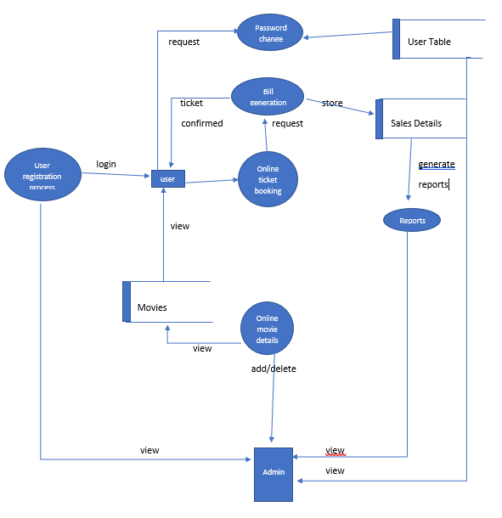

**3.3 Physical Design**

A database may be thought of as a set of related files. Related files mean that record of one file may be associated with the records in another file.

The conventional file based systems emphasized that the application and files were built around it. The database environment emphasizes the data independently of the applications that use the data.

The applications are allowed to evolve around a database design such that it can adapt to changing needs. Data becomes the central resource in the database environment.

Information systems are built around this central resource to give flexible access to data.

**3.4 Interface Design**

**3.4.1 Interface Designs**

This system contains various Forms, Buttons, Textboxes, Labels, and Tables, Combo boxes, Manuscript and Picture boxes.

There are three types of interface design available. But we use menu based interface (GUI). Because it has more advantages than other interfaces. Such as,

* Users easy to achieve the functions by selecting icons
* Users not need that much of knowledge to access the system
* Users learning time is relatively short
* Users get immediate feedback on their actions
* Easy to maintain
* Saving time wastage
* User guidance and on-line help
* Speed of use
* Support for multiple skill levels

**3.4.2 Application Interfaces**

Application Interface of the E- movie ticket booking is user friendly. Each interface has connected with database.

* When the application start to work below screen will appear

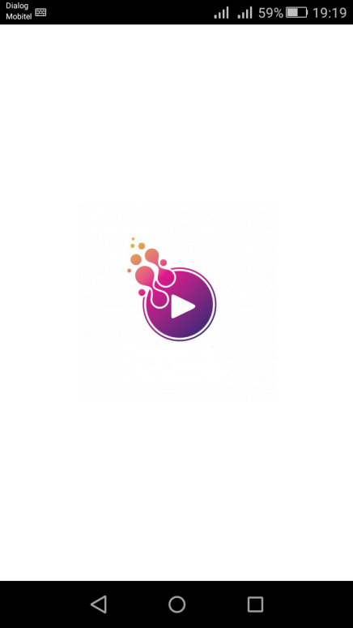

Picture 1:**Cover Page**

* A registered user Login his account on Login Page

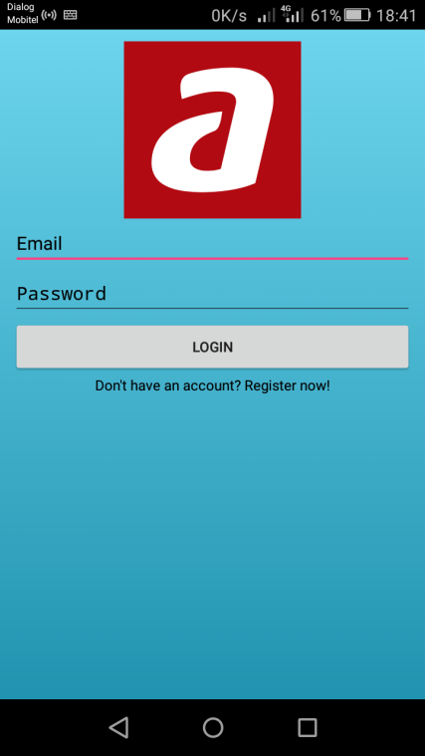

Picture 2 : **Login Page**

* A new user can create an account on Registration Page

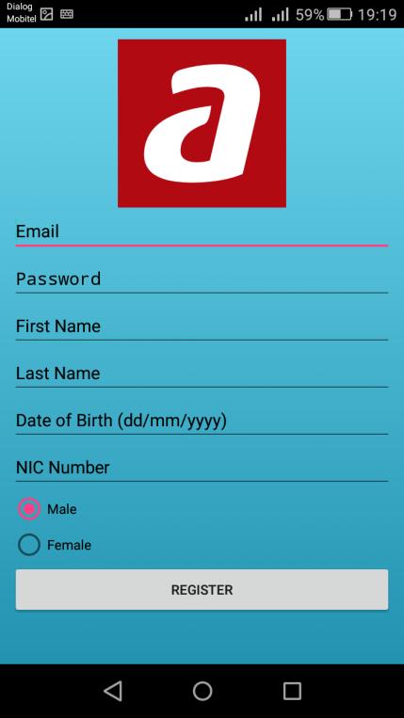

Picture 3: **Registration Page for New User**

* After login user can view the details of current shows of Movies

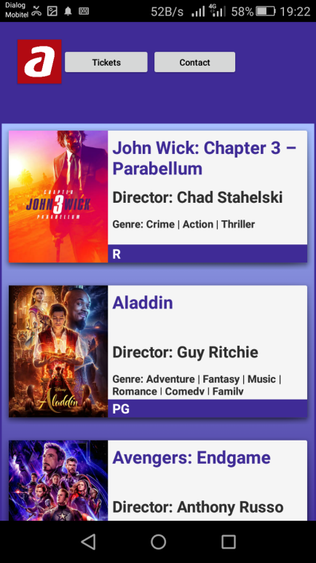

Picture 4:**List of Currently Movie Shows**

* If user wish to reserve tickets they can view the details of available seats

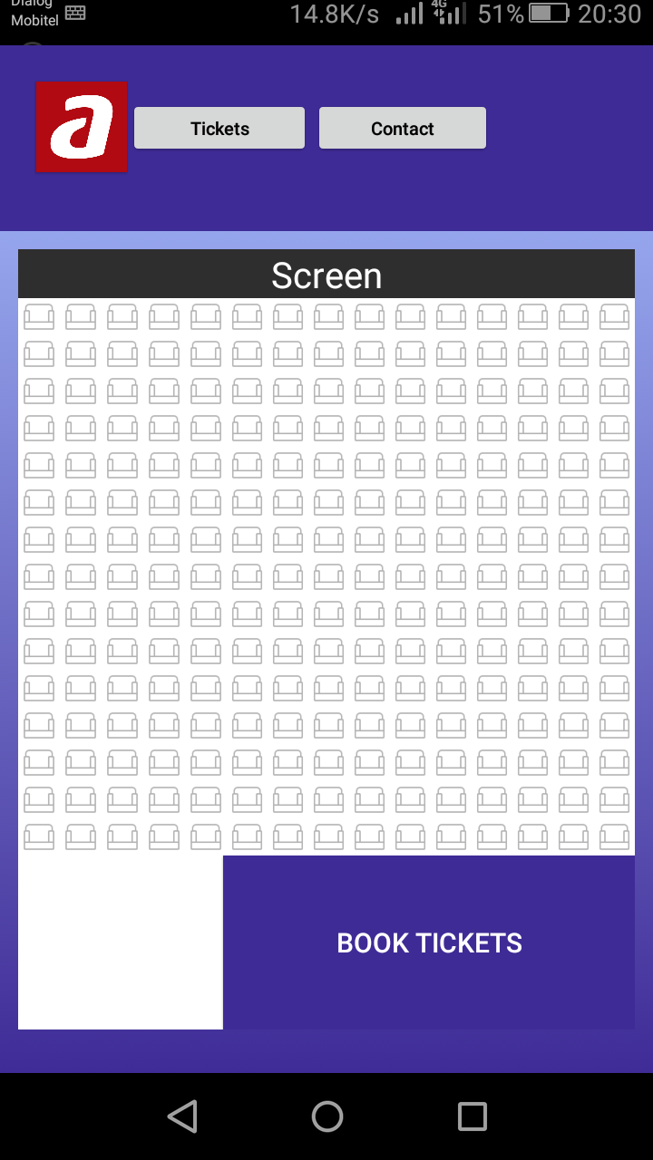

Picture 5: **View of Available Seats(Tickets)**

* User can reserve their tickets easily

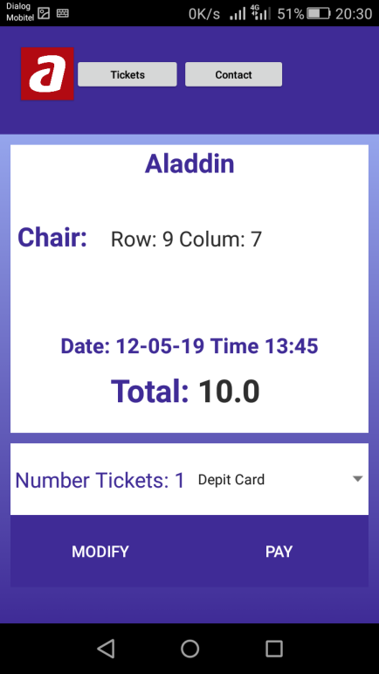

Picture 6: **Reserving Tickets**

* After reservation there a confirmation message will appear on the screen

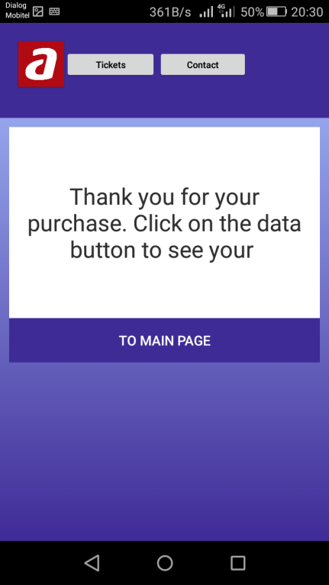

Picture 7:**Confirmation Page**

**Chapter 4**

**SYSTEM IMPLEMENTATION**

Implementation is the stage in the project where the theoretical design is turned into a working system. The implementation phase constructs, installs and operates the new system. The most crucial stage in achieving a new successful system is that it will work efficiently and effectively.

There are several activities involved while implementing a new project.

* End user training
* End user Education
* Training on the application software
* System Design
* Parallel Run and To New System
* Post implementation Review

**4.1 End user Training**

The successful implementation of the new system will purely upon the involvement of the staff working in that theater. The staff will be imparted the necessary training on the new technology

**4.2 End User Education**

The education of the end user start after the implementation and testing is over. When the system is found to be more difficult to understand and complex, more effort is put to educate the end user to make them aware of the system, giving them clarification about the new system and providing them necessary documents and materials about how the system can do this.

**4.3 Training of application software**

After providing the necessary basic training on the computer awareness, the users will have to be trained upon the new system such as the screen flows and screen design type of help on the screen, type of errors while entering the data, the corresponding validation check at each entry and the way to correct the data entered. It should then cover information needed by the specific user or group to use the system.

**4.4 Post Implementation View**

The department is planning a method to know the states of the past implementation process. For that regular meeting will be arranged by the concerned officers about the implementation problem and success

**Chapter 5**

**SOFTWARE TESTING**

➢ Software testing is a critical element of software quality assurance and represent the ultimate review of specification, design, coding. The purpose of product testing is to verify and validate the various work products viz. units, integrated unit, final product to ensure that they meet their requirements.

Is the menu bar displayed in the appropriate contested some system related features included either in menus or tools? Do pull –Down menu operation and Tool-bars work properly? Is all menu function and pull-down sub function properly listed? Is it possible to invoke each menu function using logical assumptions that if all parts of the system are correct, the goal will be successfully achieved? In adequate testing or non-testing will leads to errors that may appear few months later.

This creates two problems:

* Time delay between the cause and appearance of the problem.
* The effect of the system errors on files and records within the system

The purpose of the system testing is to consider all the likely variations to which it will be suggested and push the systems to limits. The testing process focuses on the logical intervals of the software ensuring that all statements have been tested and on functional interval is conducting tests to uncover errors and ensure that defined input will produce actual results that agree with the required results. Program level testing, modules level testing integrated and carried out.

There are two major type of testing they are:

* White Box Testing.
* Black Box Testing.
  1. **White Box Testing**

White box sometimes called “Glass box testing” is a test case design uses the control structure of the procedural design to drive test case.

Using white box testing methods, the following tests were made on the system

All independent paths within a module have been exercised once. In my system, ensuring that case was selected and executed checked all case structures. The bugs that were prevailing in some part of the code where fixed

All logical decisions were checked for the truth and falsity of the values.

* 1. **Black box Testing**

Black box testing focuses on the functional requirements of the software. This is black box testing enables the software engineering to derive a set of input conditions that will fully exercise all functional requirements for a program. Black box testing is not an alternative to white box testing rather it is complementary approach that is likely to uncover a different class of errors that white box methods like.

* Interface errors
* Performance in data structure
* Performance errors
* Initializing and termination errors

**5.3 Scope of Testing**

In my project, I had first gone for “unit testing” strategy. In which I test for the functionality of each function, after that I performed “Integration testing” where I integrated them all and tested them together.

**5.4 Test Plan**

I have gone for unit testing and integral testing. So, I have initially concentrated on unit testing and for that I spend some time whenever I developed any new functions. This has been done during coding time as well as after the design whenever I use them.

After the completion of unit testing, I have moved to integration testing and I completed it in one day.

SDLC Phase Testing Activity:

* Requirement Review
* Design Review
* Implementation Code Review Unit Testing Component Testing Integration Testing
* Testing Robustness Compatibility Load Testing Security Regression
* Deployment/Maintenance Acceptance Testing Regressions

**5.5 Test case description**

|  |  |  |  |  |
| --- | --- | --- | --- | --- |
| Test | Test Cases | Expected response From System | Success | Priority |
| 1 | User tries blank input and to login | Notifies user that the user name or password is blank | Success | High |
| 2 | User provides invalid username or password | Notifies user that the user name or password is incorrect | Success | High |
| 3 | User click forgets password. | Provided input field to enter the email address of the user. | Success | High |
| 4 | New user input details with invalid email address and details | Form validation displays errors in relevant fields. System rejects input | Success | High |
| 5 | New user tries to register with blank details | Form validation displays errors in relevant fields. System rejects input | Success | High |
| 6 | Validate user password with confirm password field | If both password and confirm passwords are similar user can proceed | Success | High |

**5.6 Validations**

No record can be saved till all the necessary entries are done.

Only administrator can perform sophisticated tasks like printing of Reports, Register new member and/or delete an existing member etc.

For security purposes the E-mail of user is required in case he/she forgets his/her password and wants to retrieve that.

**5.7 System Security Measures**

Security prompting the user for a user-id and password in our application is a potential security threat. So credential information is transferred from the browser to server are encrypted.

Security features are implemented. No unauthorized access the package, as the security is implemented through login and password.

Cookies are an easy and useful way to keep user-specific information available. However, because cookies are sent to the browser's computer, they are vulnerable to spoofing or other malicious use. So we follow these guidelines.

Do not store any critical information in cookies. For example, do not store a user's password in a cookie, even temporarily.

Avoid permanent cookies if possible. Consider encrypting information in cookies. Set expiration dates on cookies to the shortest practical time we can.

**Chapter 6**

**DATABASE MANAGEMENT**

**6.1 Database Management System**

A database is a collection of interrelated data stored with minimum redundancy to serve many users quickly and effectively. After designing input and output, the analyst must concentrate on database design or how data should be organized around user requirements. The general objective is to make information access, easy quick, inexpensive and flexible for other users. During database design, the following objectives are concerned: -

* Controlled Redundancy
* Data independence
* Accurate and integrating
* More information at low cost
* Privacy and security
* Performance
* Data backup and recovery
* Ease of learning and use

**6.2 Database Backup**

Database backup is the process of backing up the operational state, architecture and stored data of database software.it enables the creation of a duplicate instance or copy of a database in case the primary database crashes is corrupted or is lost.

**6.2.1 Backup Data**

Backup means to [copy](http://www.webopedia.com/TERM/C/copy.html) [files](http://www.webopedia.com/TERM/F/file.html) to a second [medium](http://www.webopedia.com/TERM/M/media.html) (a [disk](http://www.webopedia.com/TERM/D/disk.html) or [tape)](http://www.webopedia.com/TERM/T/tape.html) as a precaution in case the first medium fails. So, the database has day-to-day backup to saves the data from the database. Therefore, we got our backups on our external hard drive. That backup will be reused by the programmer if the database going to destroyed.

**6.2.2 Backup Media**

VCD / DVD / Rewritable CD Recordable

External hard disk

Pen drive

E-mail accounts

Google drive

**Chapter 7**

**CRITICAL APPRAISAL OF PROJECT**

**7.1 Review of the Project Development Process**

Software peer reviews are conducted by me and my colleagues, to evaluate the Technical content and quality of the product.

**7.2 Strengths and Weaknesses**

**7.2.1 Strengths**

E-Movie ticketing System has graphical user interfaces (GUI) to communicate with users.

GUIs’ are made as user friendly.

Security of the OMTBS is high.

It is made for easy to handle.

**7.2.2 Weaknesses**

If there is a power failure while making a reservation, all the information has to be enter again.

If there is a power cut while there is a check-in or check-out, the Customer need to wait for full server startup, which is time consuming.

No auto backup and online backup option available, all information will be losing in case of disk failure.

**7.3 Future Scope and further enhancement of the Project**

**7.3.1 Future Scope**

The project E-Movie ticket System for Cinema Hall is flexible enough to meet the requirements of the Customers. This project also has the scope of enhancements like:

* Home delivery of tickets may be provided.
* Online Booking of Purchases of eatables(cool drinks, popcorn etc) can be provided
* Corporate booking:Multimedia support for corporate presentation can be provided. Conference facility can be provided for corporate meetings in the hall. This will increase the profit of cinema halls as well as the company organizing event.
* Group booking :Any institute/company can book the tickets for students/clients and special discount will be provided to them

**7.3.2 Further Enhancement of the Project**

➢

Everything that is made has some or the other things to be added to make it better than revolutions.

The project “E-Movie ticket System”, it has been tried to develop a robust and fault free system, still enough flexibility has been provided for further enhancements and modifications. As I mentioned earlier then the designed forms are typically reflections of the developer, so I strongly believe that the enhancement to be done with the project to be done with the design changes, coding changes. But at the same time I would like to mention that since one can not claim himself as a master of the technology there is always some scope of technical modifications in the project that may lead to find code redundancy &storage space minimization.

Since the data is retrieved from the tables where everything is based on the coding system if the coding system is changed then the system needs to be redesigned.

**Chapter 8**

**CONCLUSION**

**8.1 Conclusion**

It has been a matter of immense pleasure, honor and challenge to have this opportunity from Grand Place Hotel to take up this project and complete it successfully. While developing this project I have learned a lot about hotel management, I have also learned how to make it user friendly (easy to use and handle) by hiding the complicated parts of it from the users. During the development process, I studied carefully and understood the criteria for making software more demanding, I also realized the importance of maintaining a minimal margin for error.

**8.2 Bibliography**

* [www.wikipedia.com](http://www.wikipedia.com)
* <https://developer.android.com/about>
* [www.bccresearch.com](http://www.bccresearch.com)
* [www.flipcrop.com](http://www.flipcrop.com)

**8.3 Reference**

* Learn Android Studio: Build Android Apps Quickly and Effectively

-By Clifton Craig, Adam Gerber

* Getting Started with Android Studio

-By Barbara Hohensee